

Foundations of Programming

Assignment No.: 14
PROBLEM STATEMENT: Write a C program to input a binary number from the user and convert it into a decimal number.

OBJECTIVE:

- To understand number system conversions.
- To learn how to convert binary numbers to decimal numbers in C.
- To practice the use of loops and arithmetic operations.
- To develop logical thinking for number system problems.

THEORY:
A binary number system uses only two digits: 0 and 1. Each digit of a binary number represents a power of 2 depending on its position. To convert a binary number into its decimal equivalent, each digit is multiplied by 2 raised to the power of its position and the results are added together. In C programming, this conversion can be implemented using loops and arithmetic operations.

PLATFORM: Linux

FLOWCHART:
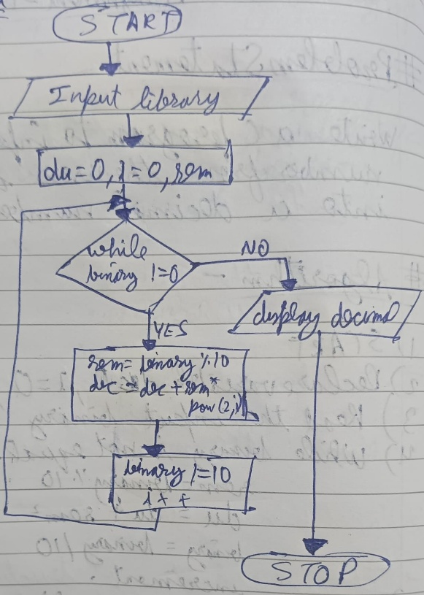

ALGORITHM:
Step 1: Start
Step 2: Declare variables binary, decimal, rem, base as integers
Step 3: Accept binary number from user and store in binary
Step 4: Initialize
decimal = 0
base = 1
Step 5: Convert binary to decimal
While binary > 0
rem = binary % 10
decimal = decimal + (rem * base)
binary = binary / 10
base = base * 2
Step 6: Display decimal number
Step 7: Stop
C PROGRAM:
#include <stdio.h>

int main() {
int binary, decimal = 0, rem, base = 1;

printf("Enter a binary number: ");
scanf("%d", &binary);

while(binary > 0) {
rem = binary % 10;

decimal = decimal + (rem * base);

binary = binary / 10;
base = base * 2;
}

printf("Decimal equivalent = %d\n", decimal);

return 0;
}

INPUT: Binary number entered by the user – 1110
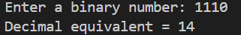

OUTPUT: Displays the decimal equivalent of the given binary number- 14

SAMPLE INPUT:
Enter a binary number: 1011

SAMPLE OUTPUT:
Decimal equivalent = 11
CONCLUSION: Thus, the C program successfully converts a binary number entered by the user into its decimal equivalent using loops and arithmetic operations.

FAQs:
- What is a binary number system?
- How is a binary number converted into a decimal number?
- What is the role of loops in binary to decimal conversion?
- What is the role of the pow() function in this program?
- What is the data type used to store binary and decimal numbers in this program?

